Chapter 09-01: Integrated Processes

PRODUCT
SAP S/4 HANA 1709
REVISED
04/20/2020
FOCUS
Procurement
Fulfillment
Production
AUTHORS
Simha R. Magal
Tom Wilder

VERSION
1.3 MCC

TESTED
Date: 04/20/2020
System: MGL

MOTIVATION
In this exercise, you will do the following for Integrated Processes:

- Create Appropriate Master Data

- Begin Fulfillment Process

- Begin Procurement Process

- Production Process

- End Procurement Process

- End Fulfillment Process
ACKNOWLEDGEMENT
These are the GBI exercises developed by Simha R. Magal and Jeff Word.

These exercises include concepts discussed in the book, Integrated Business Processes with ERP Systems (Epistemy Press, 2012).

PREREQUISITES
- You should be familiar with navigation in SAP ERP

- Completed Exercises Chs. 02-01 through 06-02, and familiar with how to perform a Stock Transport Order from exercise 07-03.



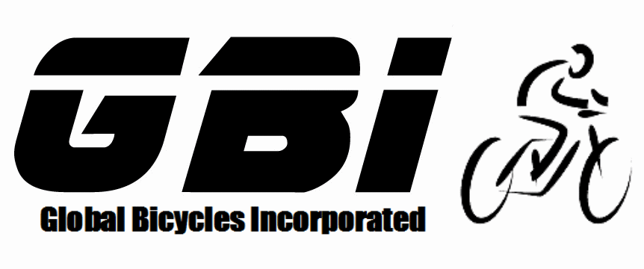

© 2020 Epistemy Press, LLC.
Screenshots © 2020, SAP SE
- Table of Contents

Table of Contents

Section 1.1: Create Appropriate Master Data Error! Bookmark not defined.
Section 1.2: Begin Fulfillment Process 5
Section 1.3: Begin Procurement Process 6
Section 1.4: Production Process 8
Section 1.5: End Procurement Process 9
Section 1.6: End Fulfillment Process 10

- Before you begin this exercise, you must ask your professor if they would like you to clear out your inventory, or if they would like you to assume that you have none of the necessary inventory.

- If Inventory needs to be cleared out, you may use movement type 562 in transaction code MB1C or you must complete the fulfilment process to clear out your plants. You only need to clear out your Dallas and Miami plants.

  - Create Appropriate Master Data

The purpose of the chapter 9 exercises is to bring together everything you have learned throughout the course. There will be very limited instructions provided as you should be referencing previous exercises whenever you are unsure of what to do. You will be required to do more than what is specifically stated in the exercise.

Before you start the entire cycle, you need to create the following master data beforehand. Notice that some master data is already created in the system from the previous exercises.

- Copy from the original Spy Gear vendor to create your own Spy Gear vendor.

- Copy from the original Beantown Bikes customer to create your own customer.
  - You will need to create this customer twice.
    - 1) Create the customer using your East Sales Organization, the Wholesale Distribution channel, and Bicycles Division.
    - 2) Create the customer using your East Sales Organization, the Wholesale Distribution channel, and the Accessories Division.
  - Use your Miami plant as the delivering plant.

- Copy from the Original Off-Road Helmets Trading Goods to create your own trading good.
  - Create the trading goods using views:
    - Basic Data 1
    - Sales: Sales Org. Data 1
    - Sales: General/Plant Data
    - Purchasing
    - Accounting 1
  - Within Miami, using your East Sales Organization, and Wholesale Distribution channel
  - Use Miami as the delivering plant.
  - Use Your Purchasing Group

- Copy from the Original Deluxe Touring Bike (Silver) finished good to create your own finished good.
  - Create the finished good using views:
    - Basic Data 1
    - Sales: Sales Org. Data 1
    - Sales: General/Plant Data
    - Work Scheduling
    - Accounting 1
    - Costing 1
  - Within Miami.
  - Use your East Sales Organization, and Wholesale Distribution
  - Use Miami as the delivering plant.

- Create pricing conditions for your Deluxe Touring Bike (Silver) and Off-Road Helmet.
  - Price Your Deluxe Touring Bike (Silver) at 2800 for your US East Sales Organization.
  - Price Your Off-Road Helmet at 50 for your US East Sales Organization.

  - Begin Fulfillment Process

In this section, you received a Purchase Order from Beantown Bikes for Five Deluxe Touring Bikes (Silver) and Fifty Off-Road Helmets in Miami. The Purchase Order Number from the vendor is 0##-41660. You will begin fulfilling this order by creating a quotation. It may help you to refresh your memory that within GBI US, although you have previously fulfilled from Miami, Miami buys and sells while Dallas produces.

- The Sales Quotation will be using the East Sales Organization and the Bicycles Division.

- Reference the Sales Quotation Number to create the Sales Order.

- When you copy your Quotation into your Sales Order, you will be brought to a screen titled “Standard Order: Availability Control”. Click on the “Continue” icon through both screens until you reach the “Create Standard Order: Overview” screen. These screens are indicating the fact that the quantity ordered is larger than how much inventory is on hand. We will address this in the last step for this exercise after your inventory is filled.
- If you get error while quotation creation, make sure to check your loading group of your material in sales/plant view of your material and refer original material to match your fields.
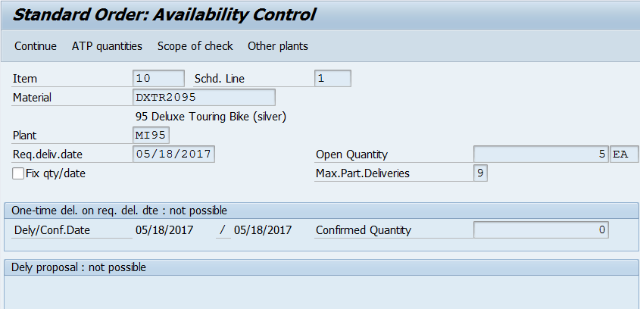

- What is the Sales Quotation document number?
- What is the Sales Order document number?

  - Begin Procurement Process

In this section, you procure the required Trading Good and Raw Materials to fulfil the customer Purchase Order. Olympic Protective Gear is your vendor that sells Off-Road Helmets and Spy Gear is your vendor that sells all Raw Materials for your Deluxe Touring Bikes (Silver). Materials are listed in the BOM for the Deluxe Touring Bike (Silver) which is shown at the end of this document. Prices for the Purchase Order are also listed at the end of this document.

- Note that from a Raw Materials perspective, the fact that we are procuring all Raw Materials is not normal. Normally, a company would procure required materials from multiple vendors.

- DO NOT use movement type 561 (“inventory from heaven”) to acquire these materials!

- Use Chapter 04 as a reference and create a Purchase Requisition for your Off-Road Helmets and another Purchase Requisition for all Raw Materials necessary to produce a Deluxe Touring Bike (Silver). Everything will be included in two requisitions due to the simple fact that we are going to be ordering from two separate vendors. Each of these will be converted into Purchase Orders.

- Use the pricing chart at the end of the document for your Purchase Order.

- Keep in mind (when ordering) that you will be producing only Five Deluxe Touring Bikes (Silver)s instead of ten.

- The required Raw Materials for the Deluxe Touring Bike (Silver) and Touring Aluminium Wheel Assembly are at the end of this document.

- Remember to think carefully about the city to which each material should be sent. For example, you are not going to order any helmets into Dallas as it is only used for production.

- How many Off-Road Helmets do you need to procure?
- How many Deluxe Touring Bikes (Silver) do you need to procure?
- What is the Purchase Requisition document number for Off-Road Helmets?

- What is the Purchase Requisition document number for Raw Materials?
- What is the Purchase Order document number for Off-Road Helmets?
- What is the Purchase Order document number for Raw Materials?
- What is the Goods Receipt document number for Off-Road Helmets?
- What is the Goods Receipt document number for Raw Materials?
- What is the Invoice document number for Off-Road Helmets?
- What is the Invoice document number for Raw Materials?
- What is the Accounting Document number for Off-Road Helmets?
- What is the Accounting Document number for Raw Materials?

  - Production Process

Now that the Raw Materials are in stock, you can begin the production process. Reference Chapter 06 to help with this section.

- Check to make sure all Raw Materials are in the proper locations for production.

- Don’t use ‘561’ movement type. Purchase all the raw materials

- Be sure that you are selecting the correct item on the stock/requirements list and the appropriate materials are going to and from the proper storage locations for production.

- What is the Planned Order document number for the Semi-Finished Product?
- What is the Production Order document number for the Semi-Finished Product?
- What is the Goods Issue document number for the Semi-Finished Product?
- What is the Goods Receipt document number for the Semi-Finished Product?
- What is the Planned Order document number for the Finished Product?
- What is the Production Order document number for the Finished Product?
- What is the Goods Issue document number for the Finished Product?
- What is the Goods Receipt document number for the Finished Product?

  - End Procurement Process

In this section, you finish the procurement process by transporting the Deluxe Touring Bike (Silver) from Dallas to Miami.

Miami is requesting the Deluxe Touring Bike (Silver) from Dallas, to receive these Deluxe Touring Bike (Silver) into Miami you will create a Stock Transport Order. Remember, Dallas is the only plant that produces and does not distribute goods to customers, so we must send the Deluxe Touring Bikes (Silver) to Miami to fulfil the Sales Order.

- Recall from Chapter 07 on how to make a Stock Transport Order.

- What is the Stock Transport Order document number?
- What is the Goods Issue document number for the stock transport order?
- What is the Goods Receipt document number for the stock transport order?

  - End Fulfillment Process

In this section, you end the fulfillment process by sending shipment and Invoice to your customer.

To tell the system that you now have sufficient inventory to fulfil the Purchase Order sent by your customer, it is highly advised to go back to your Sales Order to note the required delivery date you have entered and to make sure that multiple schedule lines disappear for all your materials. This is done in “Availability Check”. But if you already have inventory the ATP check will not be displayed. “Availability Check” will only appear if you have no inventory.

    - In the “SAP Easy Access” screen, follow the navigation path below:
Navigation
SAP Easy Access Menu Logistics Sales and Distribution Sales Order Change

    - In the “Change Sales Document: Initial Screen” screen, enter the following information:

Attribute | Description | Data Value
Order | Uniquely identifies the sales document | Your Sales Order Number

    - Click Continue .

    - In the “Change Standard Order: Overview” screen, click Select All at the bottom of the screen.

    - Click Check Item Availability .

    - In the “Standard Order: Availability Control” screen, click Complete dlv .
- You will receive a message that says, “Availability check was carried out”.

- You are performing this for both materials.

    - In the “Change Sales Order: Overview” screen, click Save .
- You will receive a message that says, “Standard Order has been saved”.

- This will now allow you to create the Outbound Delivery with reference to your Sales Order.

- What is the Outbound Delivery document number?
- What is the Invoice Billing document number?
- What is the Accounting document number for receiving the payment?

- Exercise Deliverables

Name:

Course and Section:

Identifier:

Client:

- What is the Sales Quotation document number?
- What is the Sales Order document number?
- How many Off-Road Helmets do you need to procure?
- How many Deluxe Touring Bikes (Silver) do you need to procure?
- What is the Purchase Requisition document number for Off-Road Helmets?
- What is the Purchase Requisition document number for Raw Materials?
- What is the Purchase Order document number for Off-Road Helmets?
- What is the Purchase Order document number for Raw Materials?
- What is the Goods Receipt document number for Off-Road Helmets?
- What is the Goods Receipt document number for Raw Materials?
- What is the Invoice document number for Off-Road Helmets?
- What is the Invoice document number for Raw Materials?
- What is the Accounting document number for Off-Road Helmets?
- What is the Accounting document number for Raw Materials?

- What is the Stock Transport Order document number?
- What is the Planned Order document number for the Semi-Finished Product?
- What is the Production Order document number for the Semi-Finished Product?
- What is the Goods Issue document number for the Semi-Finished Product?
- What is the Goods Receipt document number for the Semi-Finished Product?
- What is the Planned Order document number for the Finished Product?
- What is the Production Order document number for the Finished Product?
- What is the Goods Issue document number for the Finished Product?
- What is the Goods Receipt document number for the Finished Product?
- What is the Goods Issue document number for the stock transport order?
- What is the Goods Receipt document number for the stock transport order?
- What is the Outbound Delivery document number?
- What is the Invoice Billing document number?
- What is the Accounting document number for receiving the payment?

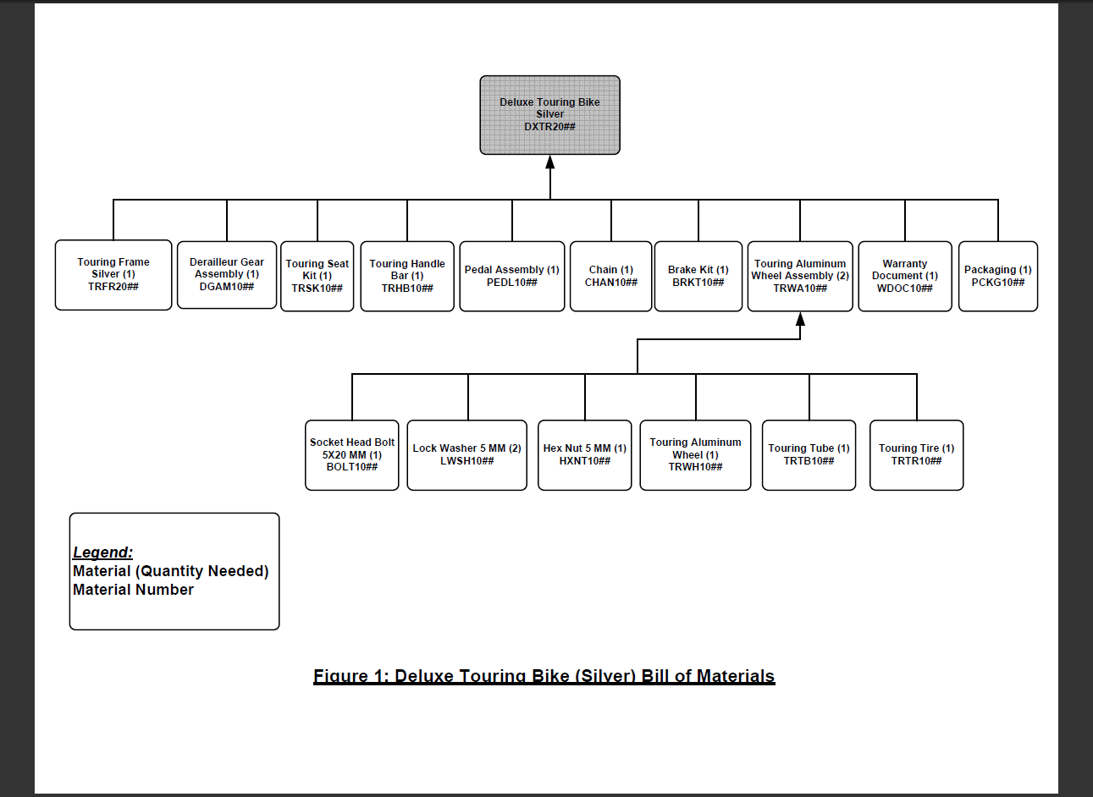

Description | Net Purchasing Price
Off-Road Helmet | $25.00
Socket Head Bolt 5x20mm | $0.10
Lock Washer 5 mm | $0.05
Hex Nut 5 mm | $0.10
Touring Aluminium Wheel | $95.00
Touring Tube | $5.00
Touring Tire | $10.00
Touring Frame-Silver | $200.00
Derailleur Gear Assembly | $75.00
Touring Seat Kit | $50.00
Touring Handle Bar | $25.00
Pedal Assembly | $45.00
Chain | $10.00
Brake Kit | $70.00
Warranty Document | $1.00
Packaging | $3.50

